**Name: Noman Sharif**

**ID: 4390**

**Discipline: Software Quality Assurance**

**Dated: October 20, 2022**

**Assignment#01**

**Work Flows of the given Website:**

Following are some of the work flows of the Website.

1. **Home to checkout work Flow for Bath Accessories:**

The work flow of home to checkout will be, if we want to purchase Bath accessories from the website.

1. **Home to Shipping work Flow for Kitchen Accessories:**

The work flow of home to shipping will be, if we want to purchase Kitchen accessories from the website.

1. **Home to My Cart work Flow for Magazines:**

The work flow of home to shipping will be, if we want to purchase Kitchen accessories from the website.

1. **Home to My Account work Flow:**

Thework flow to make an account in the website is given by following.

1. **Home to Billing Method work Flow for Utility:**

The work flow of home to Billing will be, if we want to purchase Utility accessories from the website.

1. **Home to Payment work Flow for Bath Accessories:**

The work flow of home to Payment will be, if we want to purchase bath accessories from the website.

# **Bugs in the given Website:**

# **1) Help & FAQ button doesn’t do anything**

Users should be able to view instruction or help to perform their desired action. This should also include frequently asked questions.

|  |  |  |  |
| --- | --- | --- | --- |
| Severity | Issue type | Frequency | Environment |
| Medium | functional | Every time | All browsers |

## **Action Performed**

Open the [Vue Storefront and BigCommerce | Vue Storefront Demo](https://demo.vuestorefront.io/)

Click on “Help & FAQ” on top left corner

## **Expected Result**

Help and FAQ should be loaded

## **Actual Result**

It does not do anything

## **Attachments**

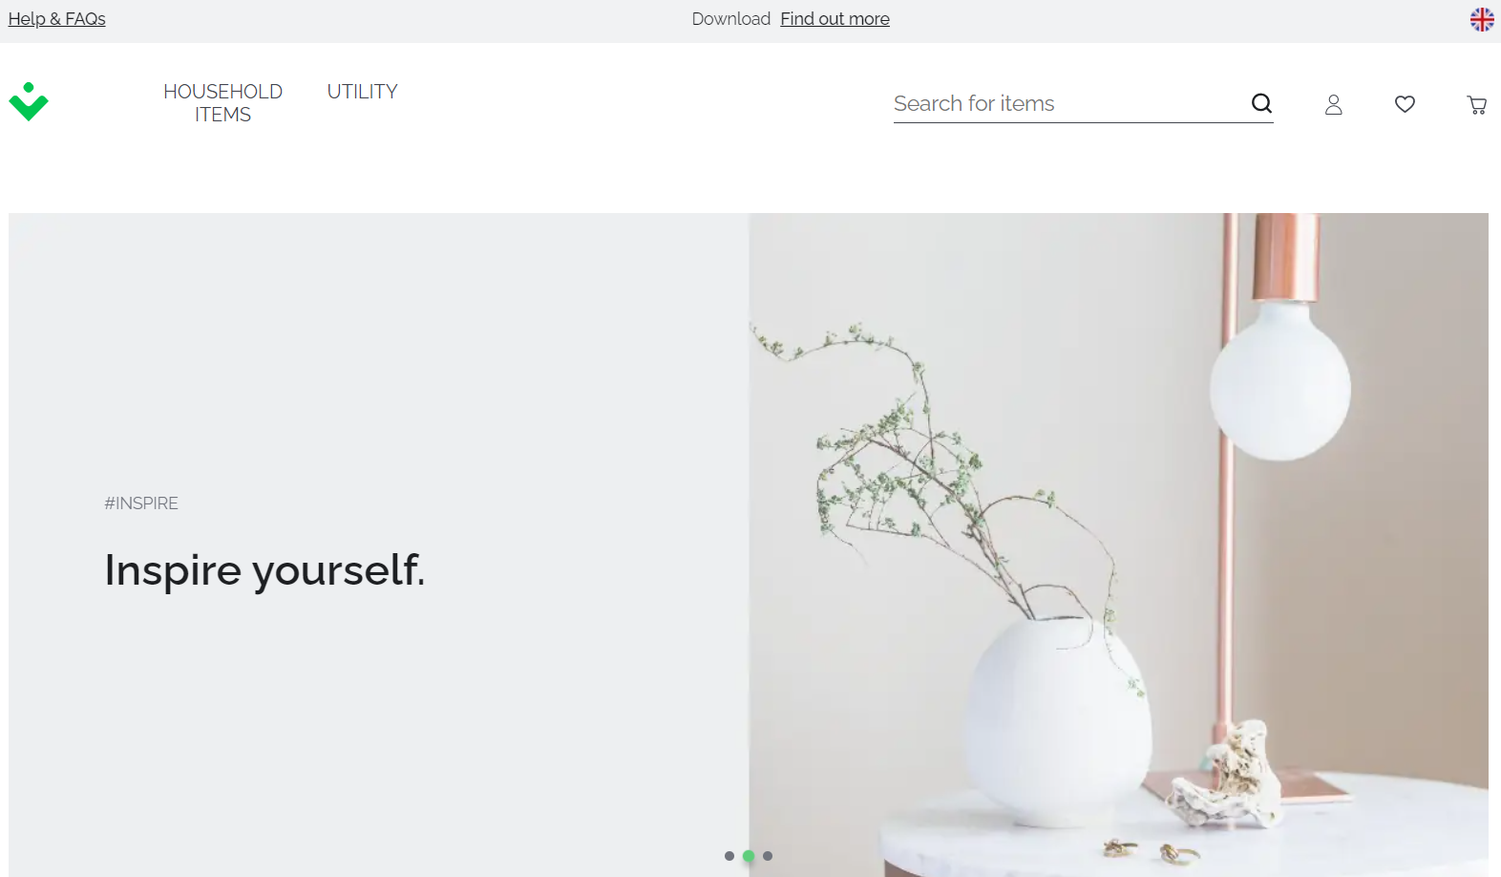

# **2) Find out more button doesn’t do anything**

Users should be able to see more products or services.

|  |  |  |  |
| --- | --- | --- | --- |
| Severity | Issue type | Frequency | Environment |
| Low | functional | Every time | All browsers |

## **Action Performed**

Open the [Vue Storefront and BigCommerce | Vue Storefront Demo](https://demo.vuestorefront.io/)

Click on “Find out more” on top middle.

## **Expected Result**

Find out more should be loaded

## **Actual Result**

It does not do anything

## **Attachments**

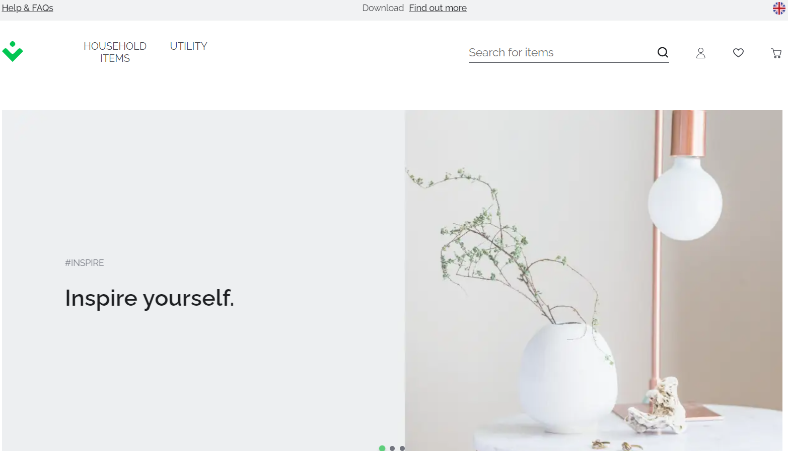

# **3) Buttons in the footer doesn’t work**

None of the buttons in the footer work.

|  |  |  |  |
| --- | --- | --- | --- |
| Severity | Issue type | Frequency | Environment |
| Medium | functional | Every time | All browsers |

## **Action Performed**

Open the [Vue Storefront and BigCommerce | Vue Storefront Demo](https://demo.vuestorefront.io/)

Scroll down to the end of the page.

Click on any button in the footer

## **Expected Result**

Clicking on the button should open relevant web page.

## **Actual Result**

Buttons doesn’t lead to anywhere.

## **Attachments**

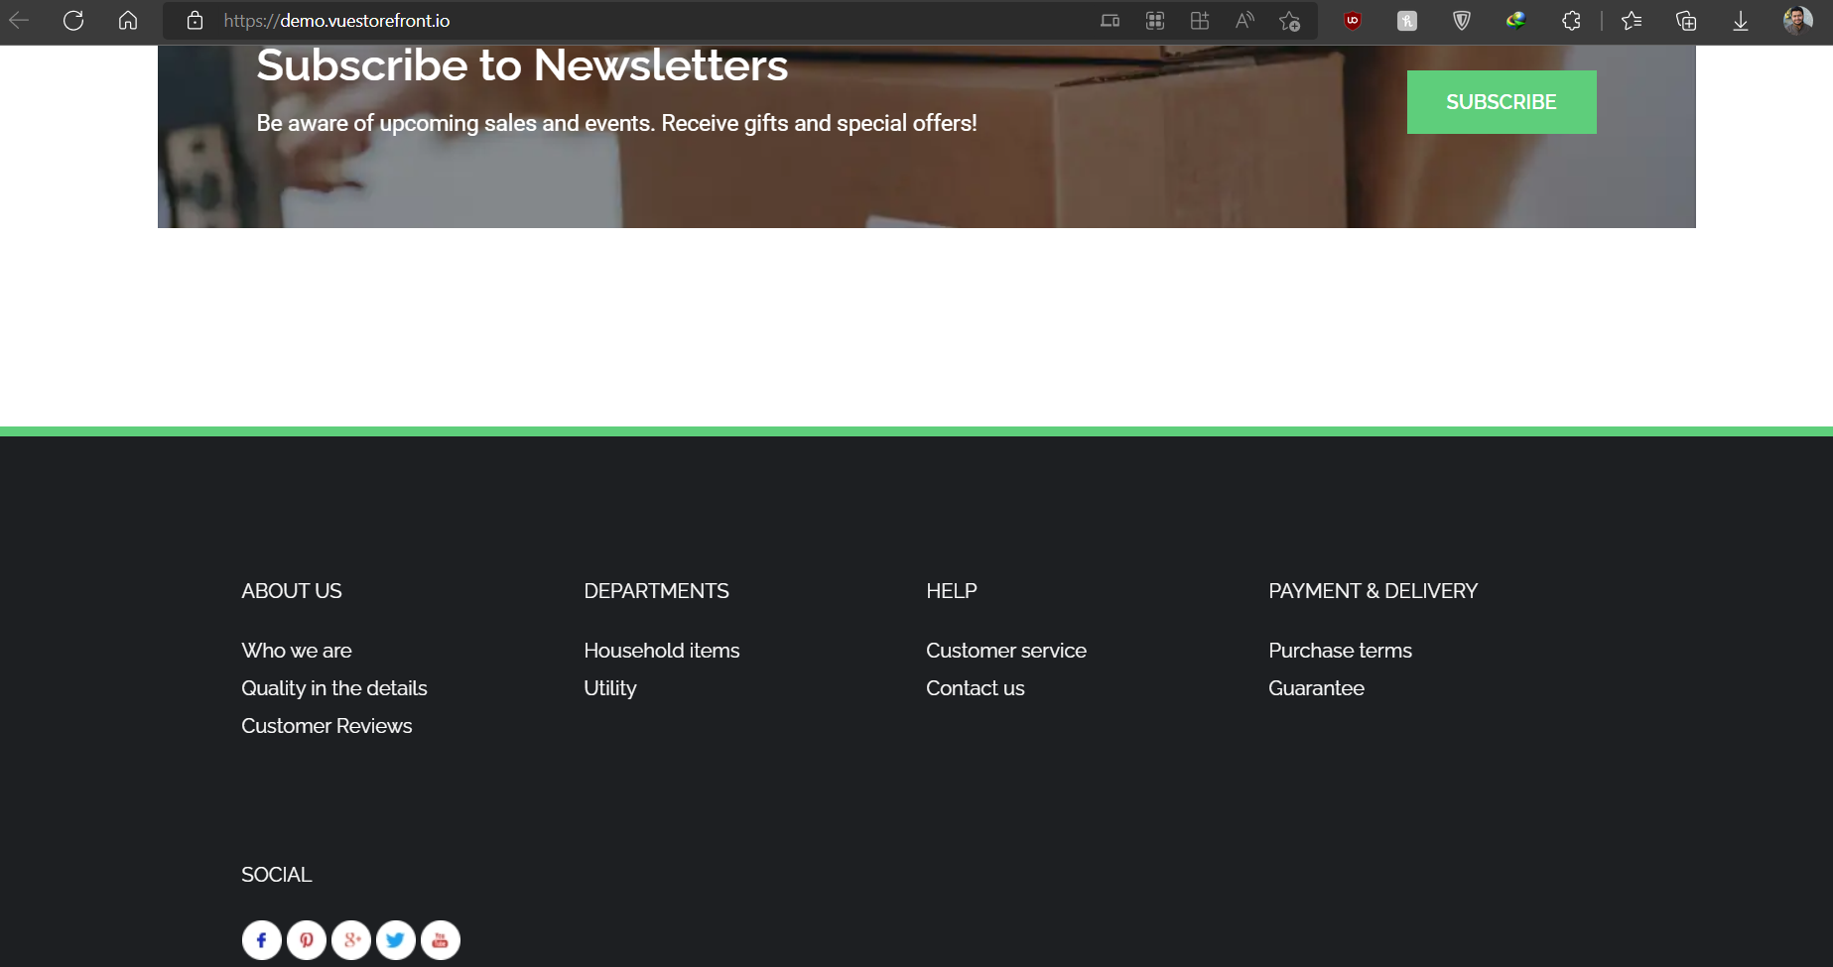

**4) Social media buttons in the footer doesn’t work**

None of the buttons in the footer work.

|  |  |  |  |
| --- | --- | --- | --- |
| Severity | Issue type | Frequency | Environment |
| Medium | functional | Every time | All browsers |

## **Action Performed**

Open the [Vue Storefront and BigCommerce | Vue Storefront Demo](https://demo.vuestorefront.io/)

Scroll down to the end of the page.

## **Expected Result**

Clicking on the button should open relevant web page.

## **Actual Result**

Buttons doesn’t lead to anywhere.

## **Attachments**



**Missing Scenarios in Website:**

1. **Missing Shop Now Tag on Two Products:**

The Shop Now Tag is missing on both utility advertisement in the Website.

 

1. **Missing “Forgot Passward ” Option:**

The option for forgot Passward is not there in the window of My Account in the Website.

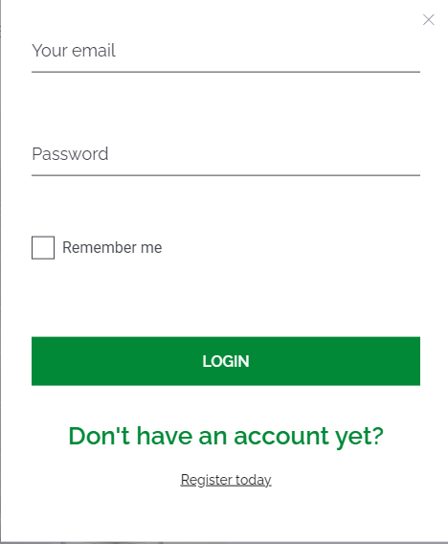

1. **Bath, Kitchen and Magazines advertisement are Missing:**

The advertisement of Bath, Kitchen and magazines are missing in the Home page of the Website.



1. **No “Cash On Delivery” Option Available in Payment Method:**

Almost in every Website COD option is available for the customer if he/she has no option without that, but here in this website COD option is missing.

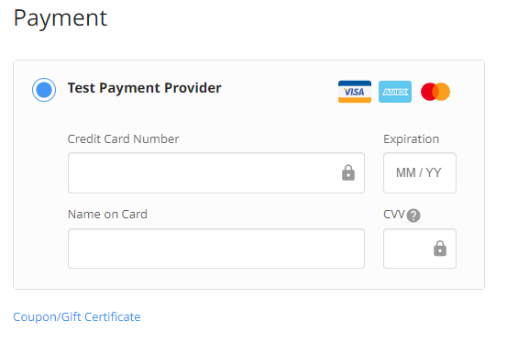

**Functionalities of WhatsApp Application:**

**Following are some of the functionalities of WhatsApp.**

1. **Block unwanted people and spam**
2. **Add dates to your calendar**
3. **Protect your chats – disable notification preview**
4. **Send a single message to multiple people at once**
5. **Make voice calls**
6. **Read messages without blue ticks**
7. **Format your text**
8. **Find out who you chat with a lot**
9. **Save data when using WhatsApp on Mobile networks**
10. **Control your privacy**
11. **Share documents**
12. **Stop auto download of photos and videos to save data**
13. **Add shortcuts to your home screen for individual chats**
14. **Send messages to yourself.**
15. **Transfer files between PC and mobile**